Wear - Buster F-DLC
Principle of F-DLC coating

The F-DLC film is coated in a plasmatic environment with ionized gases. These ionized gases are induced with electric and magnetic field to impact into the substrate.
Properties of F-DLC coating

Low friction
Wear resistance

Corrosion resistance

Welding resistance

F-DLC is an amorphous structure of SP2-SP3. The surface of F-DLC (pic.1) is smoother than TiN (pic.2) and has a lower coefficient of friction than normal DLC. The coefficient of friction of F-DLC is between 0.05~0.1, which makes F-DLC better than normal DLC in wearing resistance and welding resistant.
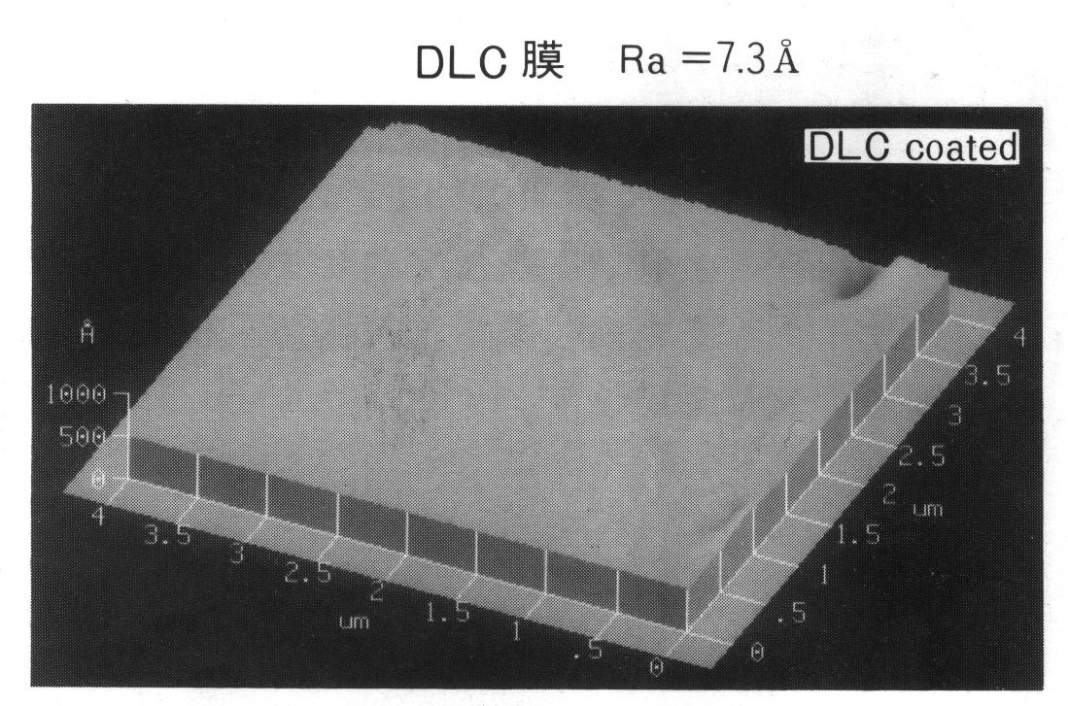
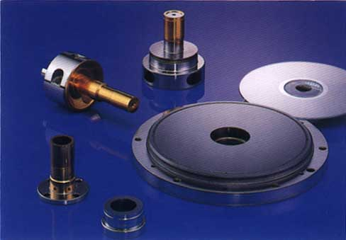
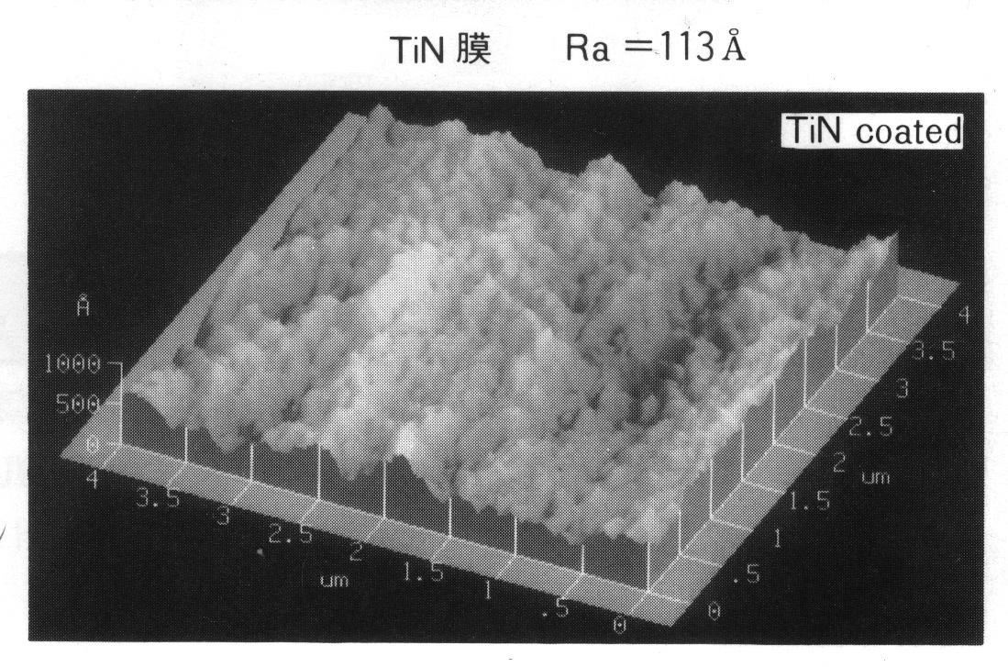

(Pic.1)

Molds of Optical Disk
˙sales and supplying
˙coating
˙recovery

(Pic.2)

Excellent adhesion
Long lifetime

F-DLC (pic.3) is also better than normal DLC (pic.4) in adhesion.
By performing a HRC test, we found that normal DLC coating is easier to peel off than F-DLC. With better adhesion, the lifetime of the tool coated with F-DLC should be prolonged.
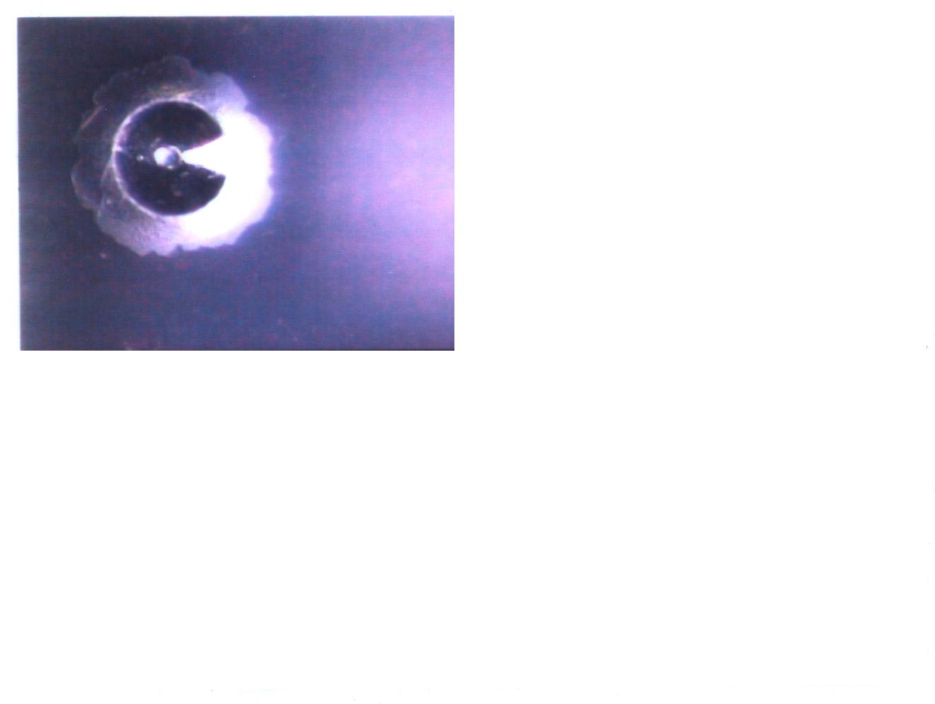
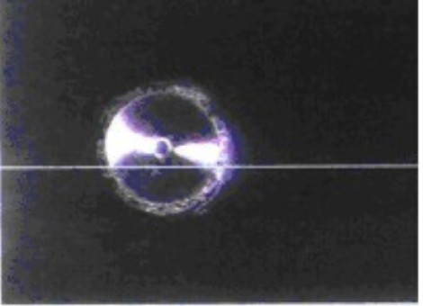
(Pic.4)
(Pic.3)

Comparison of F-DLC, Normal DLC and TiN

Properties | TiN | Normal DLC | F-DLC
Color | gold | black | black
Microhardness | Hv2000-2400 | Hv1000-1700 | Hv1800-2100
Thickness | 1-4µm | 1-2µm | 2-4µm
Coating temperature | 300-500℃ | 100-250℃ | 100-250℃
Coefficient of friction | 0.5 | 0.1-0.2 | 0.05-0.1
Adhesion | ☆☆☆ | ☆ | ☆☆☆

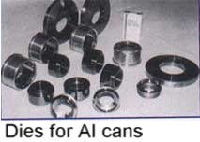
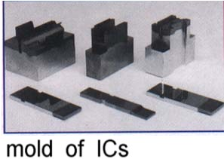
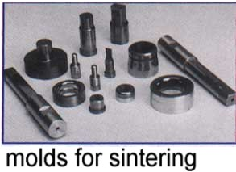

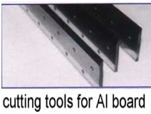
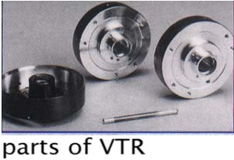

COSMOVAC Industrial Co., Ltd.
No.135,Ho-Ping E Rd.,Yungkang City,Taiwan.
TEL:886-6-2533371 FAX:886-6-2539248
http://www.cosmovac.com
e-mail:cosmovac@cosmovac.com

